|  |
| --- |
| Experiment No. 9 |
| Program to manipulate arrays using NumPy |
| Date of Performance: |
| Date of Submission: |

**Experiment No. 9**

**Title:** Program to manipulate arrays using NumPy

**Aim:** To study and implement arrays manipulation using NumPy

**Objective:** To introduce NumPy package

**Theory:**

**Numpy**is a general-purpose array-processing package. It provides a high-performance multidimensional array object, and tools for working with these arrays. It is the fundamental package for scientific computing with Python.  
Besides its obvious scientific uses, Numpy can also be used as an efficient multi-dimensional container of generic data.

#### *Arrays in Numpy*

Array in Numpy is a table of elements (usually numbers), all of the same type, indexed by a tuple of positive integers. In Numpy, number of dimensions of the array is called rank of the array.A tuple of integers giving the size of the array along each dimension is known as shape of the array. An array class in Numpy is called as **ndarray**. Elements in Numpy arrays are accessed by using square brackets and can be initialized by using nested Python Lists.

**Creating a Numpy Array**  
Arrays in Numpy can be created by multiple ways, with various number of Ranks, defining the size of the Array. Arrays can also be created with the use of various data types such as lists, tuples, etc. The type of the resultant array is deduced from the type of the elements in the sequences.  
**Note:** Type of array can be explicitly defined while creating the array.

**Code:**

import numpy

a = numpy.array([1,2,3,4,5])

x = int(input('Select the index of the number you want too search [1,2,3,4,5]\nEnter Number:'))

print("Elements: ",a[x])

total = sum(a)

**Output:**

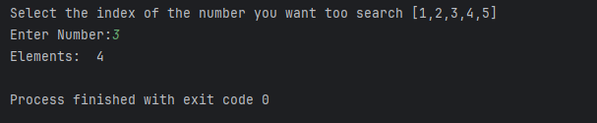

**Conclusion:** NumPy is a powerful library for numerical computing in python. It provides efficient and convenient operations for manipulating arrays, such as mathematical operations, reshaping, transposting, and statistical computations. With NumPy, you can perform complex computations on large datasets with ease, making it a valuable tool for data analysis, machine learning, and scientific computing.Its extensive functionality and ease of use make it a preferred choice for array manipulation tasks in python.